Project Proposal for Deep Learning and Data Science

Nathan Cho

Using network embedding methods on ordinal data

Unlike cardinal numbers, ordinal numbers are numbers that show orders without giving information about size. They are widely used, for example, in Economics, where preference relations give information about the choices of the consumer. They could also be used in sport climbing, which has been newly added to the 2021 Tokyo Summer Olympics. In sport climbing, each problem has its own difficulty, although each individual might disagree on specific grades, there is usually not that much difference in opinion. For example, in the Hueco scale, where each problem is in the range from V0 to V17, disagreements are usually within the range of 1 or at most 2.

Each climbing gym or natural rock has its own unique features, such as terrain and rock friction that make the comparisons difficult. One way to make comparisons possible is standardization. A few companies have developed standard boards which have the exact same layout for anyone. One such company, KILTER, LLC, makes the Kilter Board, which has around 40,000 problems. An example of a problem is shown below. Climbers are only allowed to use the holds that are circled by the problem, and climbs are completed when they reach the pink circle.

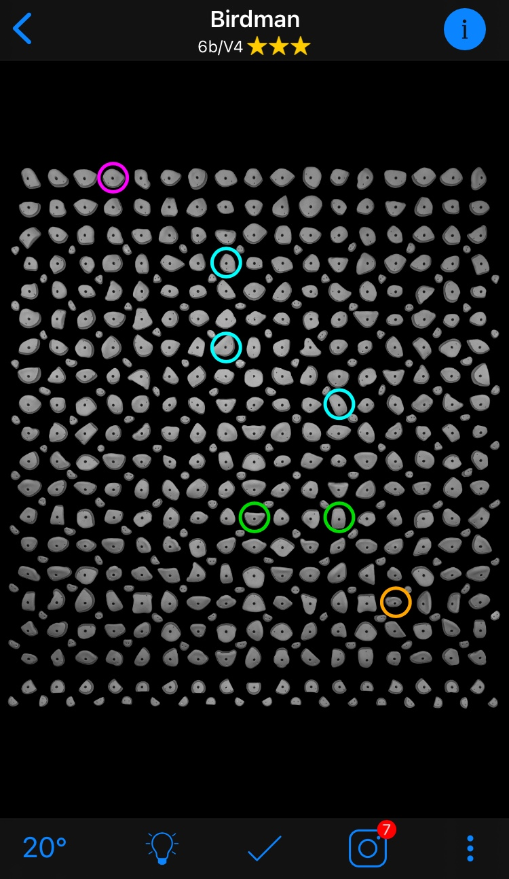

As mentioned before, each problem is subjective. Thus for an individual, one V4 problem may be easier than another V4 problem. My research goal is to check and see if these problems can be embedded on to a space so that we can visualize and classify problems according to difficulty. I believe this will be more difficult than binary classification, since we have 18 groups, but the fact that the data have an order may simplify the problem immensely. One application of the research could be for the algorithm to be applied to new problems that nobody has tried out before, so that climbers attempting to solve a new problem would have a better idea about what the difficulty will be.